**Assignment 2:**

1:Sales By Customer

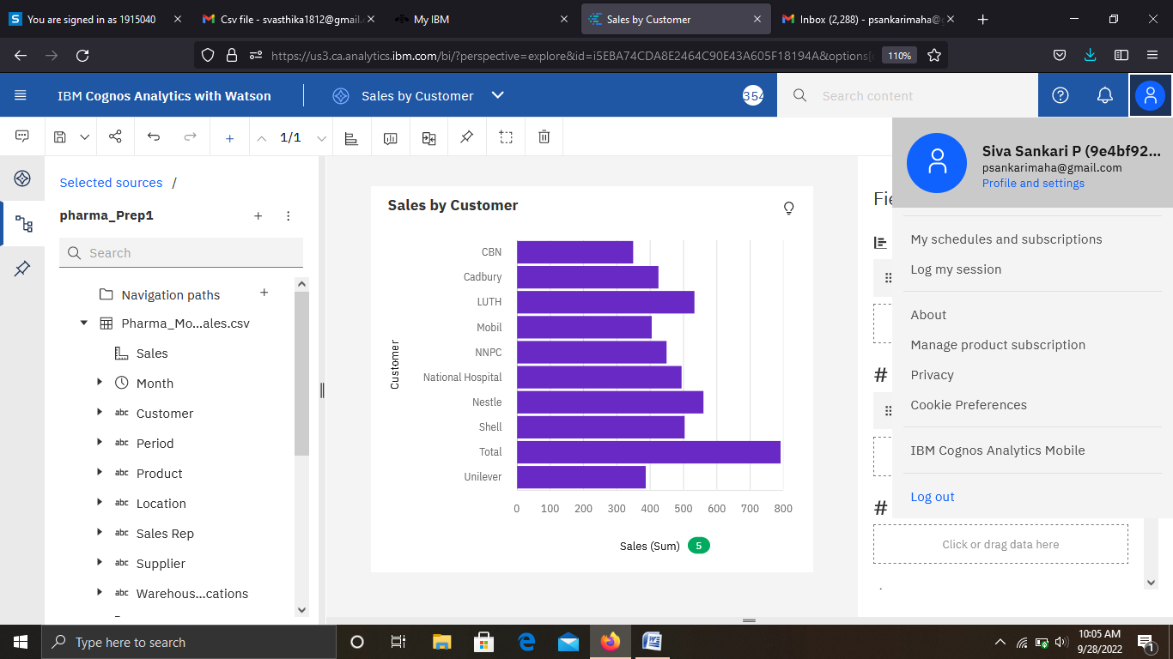

<https://us3.ca.analytics.ibm.com/bi/?perspective=explore&pathRef=.my_folders%2FSales%2Bby%2BCustomer&subView=model00000183826005b3_00000000>

2:Sales By Location

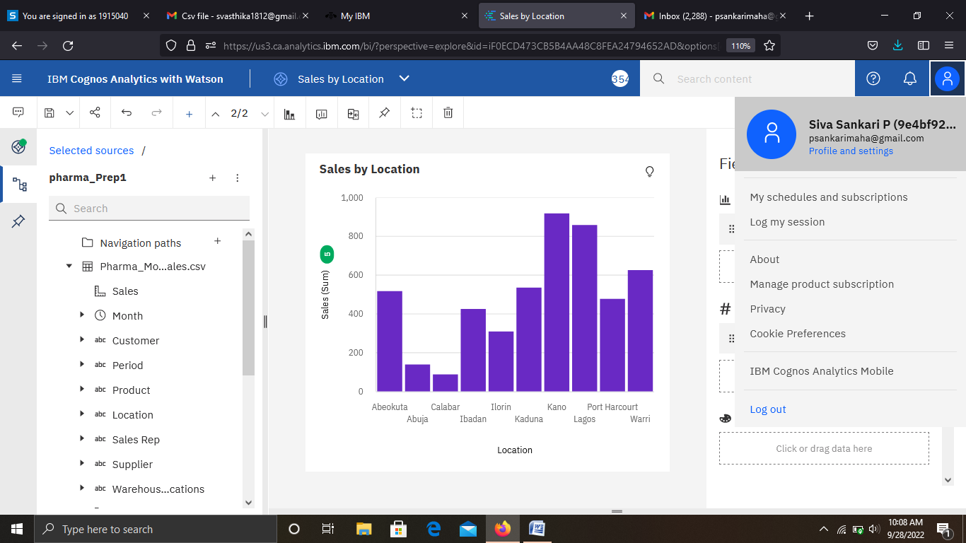

<https://us3.ca.analytics.ibm.com/bi/?perspective=explore&pathRef=.my_folders%2FSales%2Bby%2BLocation&subView=model000001838261c8dd_00000000>

3:Sales By Sales Representative

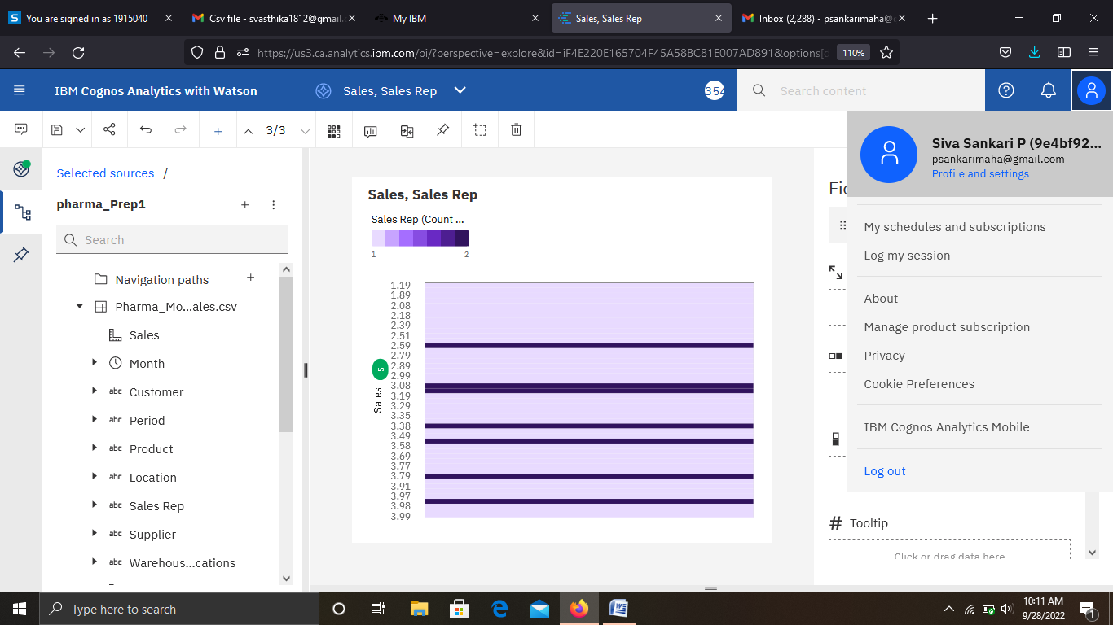

<https://us3.ca.analytics.ibm.com/bi/?perspective=explore&pathRef=.my_folders%2FSales%252C%2BSales%2BRep&subView=model0000018382644814_00000000>

4: Received Inventory From Supplier

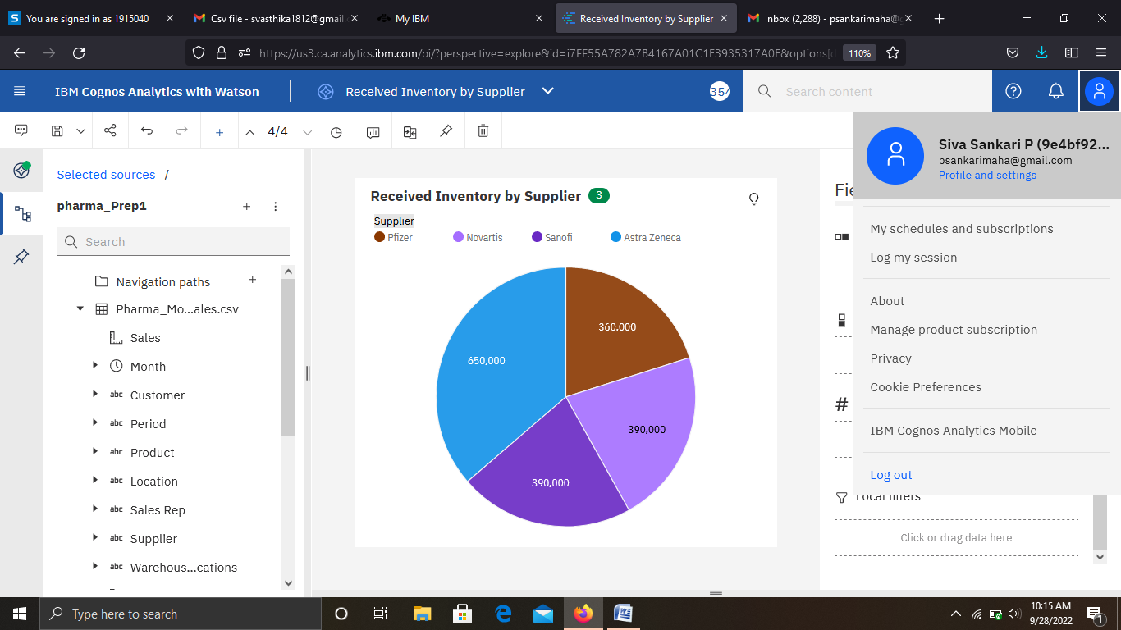

<https://us3.ca.analytics.ibm.com/bi/?perspective=explore&pathRef=.my_folders%2FReceived%2BInventory%2Bby%2BSupplier&subView=model0000018382678269_00000000>

5: Inventory Stock for Warehouse Locations

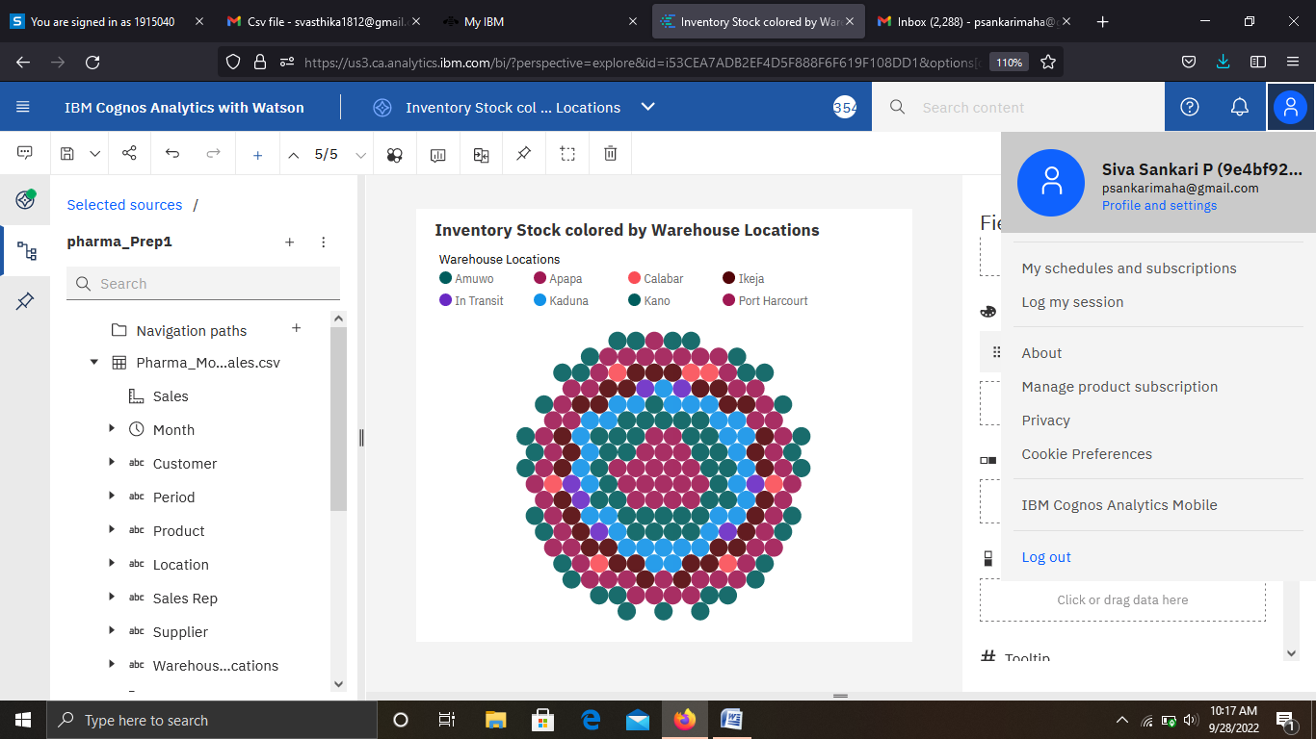

<https://us3.ca.analytics.ibm.com/bi/?perspective=explore&pathRef=.my_folders%2FInventory%2BStock%2Bcolored%2Bby%2BWarehouse%2BLocations&subView=model00000183826a4d09_00000000>

6: Sales Trend

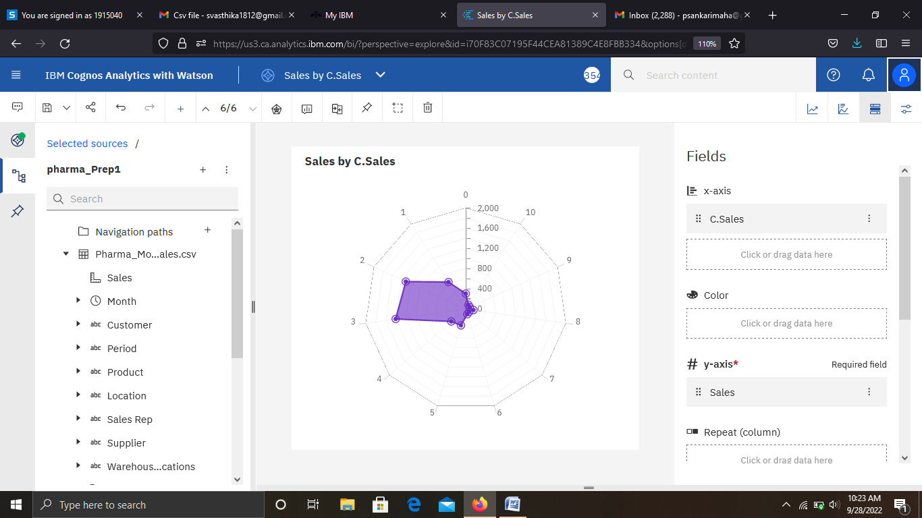

<https://us3.ca.analytics.ibm.com/bi/?perspective=explore&pathRef=.my_folders%2FSales%2Bby%2BC.Sales&subView=model00000183826d8534_00000000>

7:Monthly Sales

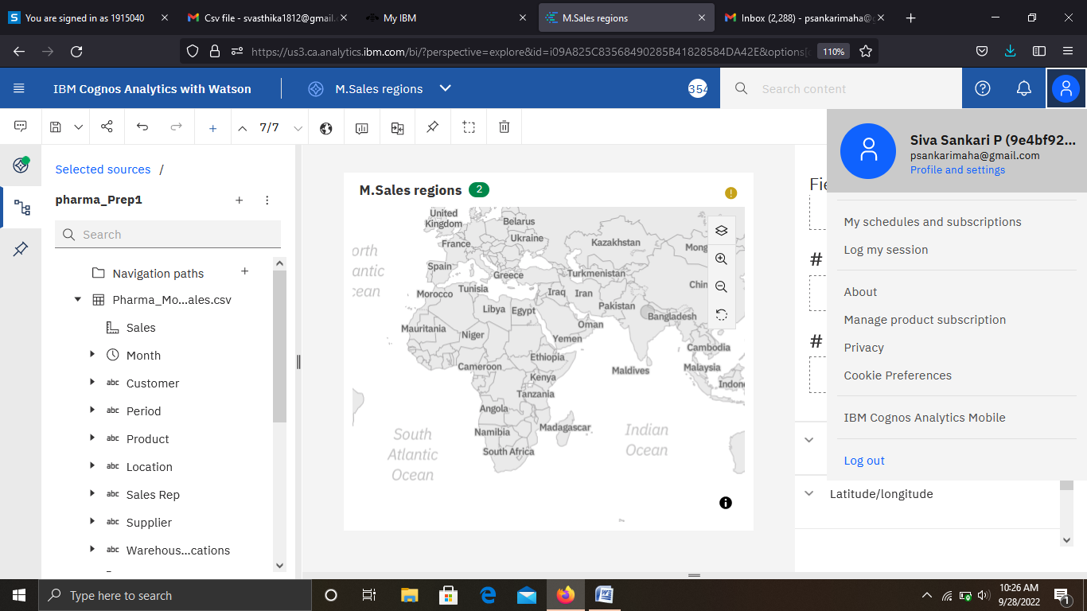

<https://us3.ca.analytics.ibm.com/bi/?perspective=explore&pathRef=.my_folders%2FM.Sales%2Bregions&subView=model00000183827263a1_00000000>

8: Actual and Received Inventory by Month

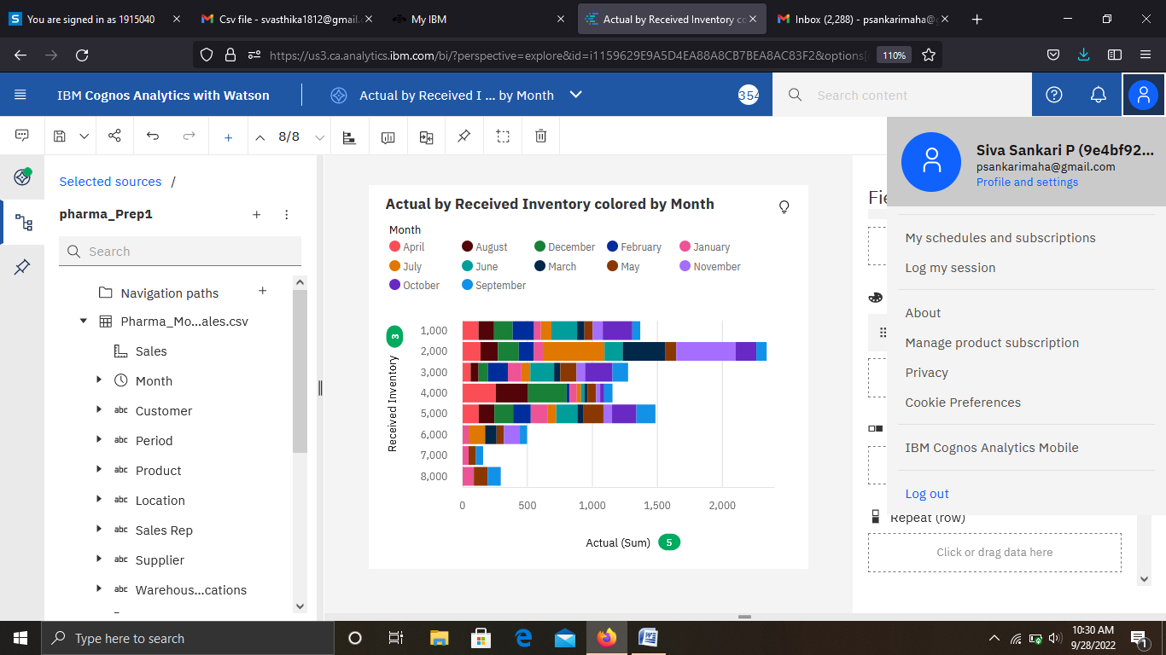

<https://us3.ca.analytics.ibm.com/bi/?perspective=explore&pathRef=.my_folders%2FActual%2Bby%2BReceived%2BInventory%2Bcolored%2Bby%2BMonth&subView=model000001838275ea37_00000000>

Dashboard:

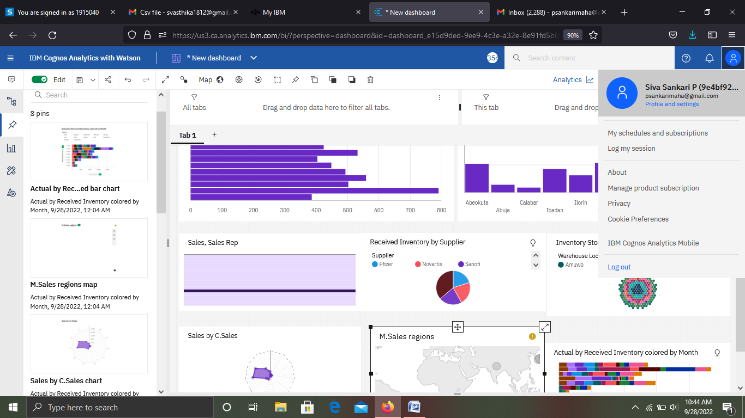

<https://us3.ca.analytics.ibm.com/bi/?perspective=dashboard&pathRef=.my_folders%2FPharma_Dashboard&action=view&mode=dashboard&subView=model00000183827c5dd7_00000002>